The Girl Goes Missing

“Star Witness” by Joe Meno: Episode One
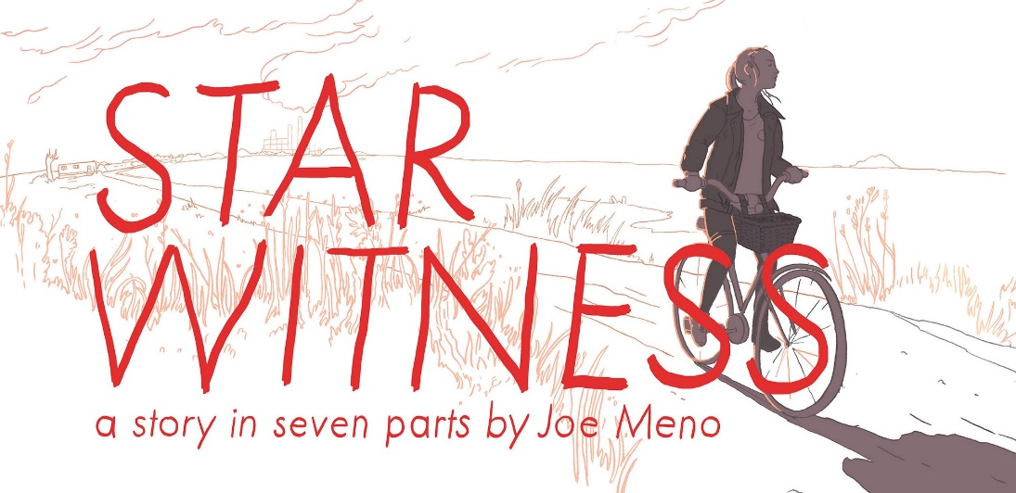
New episodes of “Star Witness” are published every Friday. Read the next episode, and find out more about “Star Witness” here. Become a member for exclusive access to the audio editions of each episode.
Continue reading Episode 2: Shelley Enters the Woods.

1.On the way home, the girl did not notice the color of the sky or the shape of the night, as she was too busy questioning why there were no secrets anymore.
She pedaled past the town square, the abandoned shops, the gas station sign flickering in its insignificance, feeling upset. Everything — the empty roads and lonely looking houses set far back from the road, the dilapidated buildings spaced several hundred yards apart — seemed to lack mystery.
Even the diner, where she had spent the better part of the past nine hours on her feet waiting tables, was no place for anything fascinating or curious. Before her shift ended, her boss, Mr. Dupont, had the nerve to accuse her of daydreaming and flirting with one of the short-order cooks. Out of embarrassment — for the accusation was partly true — Shelley had turned and spilled an entire tray of ice cream, then mumbled a few extraordinarily tame epithets. She repeated these now as she rode: “Oh Hell and Holy Ghost.”
Her one good pair of nylons now had a rip somewhere at the back of her right thigh, which had happened when she knelt down to clean up the overturned dessert. Although she tried to ignore it, she could feel the broken seam inching up her leg as she rode along, reminding her of everything that had gone wrong that day.
Sometimes 19 was too young and too old at exactly the same time.
The girl had an interesting face — almost anybody could see. Her brown eyes were flecked with green, and her expressions usually carried an open, questioning quality that most people considered friendly or unserious.
Up the back stairs, she could hear her grandmother speaking to somebody inside the kitchen. As Shelley approached the door, she realized her grandmother was talking to herself once again, addressing the dozens of photos of her former kindergarten students that were posted on the refrigerator. She was reciting a familiar story to them, her voice punctuated by the sounds of the police scanner buzzing faintly on the kitchen table and the chatter of Mr. Peepers, their pet bird, in his cage by the window. Shelley stood by the screen door and listened quietly.
“Then, of course, there was the sly fox,” her grandmother said. “He played the fiddle so sweetly that it sounded like a mother bird singing to her young. And he would hide out in the woods, just beyond the shadowy fields, and he would play his fiddle at midnight, and all the chickens would begin pecking at their doors. And then the fox, he would begin to play quieter and quieter, and all the hens in the henhouse would begin fussing until they had each crept out, and they would scoot across the field and into the dark shadows of the midnight woods, and one by one, the fox would wring their necks and gobble them up in his razor-sharp mouth.”
2.Shelley entered the kitchen and found her grandmother at the table, putting a blob of white frosting on an uneven red velvet cake. She leaned over and kissed her grandmother on her powdery forehead, then stood on tip-toe to put a wad of cash into the coffee can on top of the refrigerator.
It was only 6 p.m. on a Friday, and all she wanted in the world was for the day to be over.
“Don’t you look bushed?” her grandmother said with a grin, keeping one hand on the frosting knife, the other on the cake plate.
“I am.” Shelley collapsed into a seat at the opposite end of the table, took off one of her canvas tennis shoes, and began massaging her left foot. “I swear I must have walked as far as China, running back and forth from that kitchen all day.”
“You want me to draw you a bath?”
“No thanks. I’ll just sit here a minute,” she said, putting her feet up on the empty chair beside her. “I tell you, I just can’t believe how unfair the world is.”
“Now why’s that?” her grandmother asked.
“Because Wayne and I got in a load of trouble at work today. He was back at the grill and the only one working on the line through the rush, and wouldn’t you know there was some kind of outfit moving these little yellow houses on the back of their trucks—five or six of them on these flatbed trucks—and Wayne and I were staring out the window daydreaming, and he asked me if maybe I’d like to sneak into one of the houses with him. Like we could live together, and our kids would never have to go to school, and we could see the whole world traveling around like that. I said I’d like to, but then a bunch of orders got called up, and he ended up burning some eggs. Then Mr. Dupont came up and laid into us about paying attention instead of spending our time daydreaming and love-talking. Then I got upset and dropped a tray of ice cream. And I had to pay for it out of my tips.”

Her grandmother smiled, adding another glob of frosting. Glancing up, she said, “Don’t move. You look just like the picture of your mother sitting there.”
Shelley frowned, ignoring the comment. “Is that for the cakewalk tomorrow?”
“It is.”
“The sheriff picking it up?”
“Said he would.”
Shelley looked across the small linoleum table and again noticed that the police scanner volume had been turned all the way up. It chirped with a far-off though consistent static. Her grandmother’s black-and-white composition book was open to a page where she had scribbled something nearly illegible. “What’s that?” Shelley asked.
“We got a new one today: 11-26. Abandoned bicycle.”
“Oh, that is new. I never heard that one before.”
“It is. I had to check the code book myself.” Her grandmother leaned forward conspiratorially. “A call came from over at Wright and Evergreen about 20 minutes ago. Somebody found a bicycle just sitting next to the curb. No one knows whose it is. Gary Polk’s the officer on the scene.”
“Gary Polk? Oh, I don’t like him at all. He came into the diner yesterday and looked me up and down like I was a pony at the 4-H. And when I walked past him, he pinched my behind. I like Deputy Will better. He’s tall…and nice. He never tries to make a grab at anyone.”
“You just be thankful someone makes a grab at you every so often.”
“Very funny,” she said. “Anything else exciting happen?”
“Well, earlier there was a 10-91A. A stray animal. It was the Hanford’s cat that run away. The black one. It was at the grocery store. It went inside, right down to where the cat food aisle was. Mrs. Hanford had to come pick it up. By the way, did you hear that Junior Hanford’s back in town?”
“No. I didn’t.”
“I thought you used to have quite a thing for him.”
“I never did!”
“When you used to pal around with his sister. You had a crush on that boy. I believe you were in the fifth grade, and Junior was in the eighth.”
“I shouldn’t have ever told you,” Shelley said with a short smile. “But you always find a way to wheedle things out of me.”
“It just so happens that I can’t abide secrets, big or small.”
The police scanner interrupted with harsh static.
“Unit 304 to base. Located the bicycle. It’s a girl’s one. Pink, with streamers. Going to try and find out who it belongs to. Over.”
“Ha. Some mystery,” Shelley sulked. “Friday night and this is all the excitement they got for us.” She took out her pad from work and began to finish a sketch she had started earlier in the day.
Over the past several months, the girl had begun using the ticket book from the diner as a kind of notepad, drawing the lunch counter’s customers in a series of furious lines and curves. They looked like a series of police sketches. More than once, Shelley had followed customers home after her shifted ended, adding details about the kinds of cars they drove, where they lived, what their houses looked like—a rogue’s gallery of all the interesting inhabitants of town. She was now working on a drawing of a man who had come into the restaurant the day before — Raymond Dove — a felon, known arsonist, and suspected methamphetamine distributor who had a wide, rangy-looking face and one arm that was noticeably shorter than the other. She now settled into the drawing, ignoring the subtle buzz from the scanner until it abruptly announced:
“Unit 304 to base. Approaching a group of kids on the corner of Fourth. One of them gave me the finger. Think it was Mike Lee’s son. Going to ask them who this bike belongs to. But are you sure the sheriff don’t have anything better for me to do than chasing kids around?”
It was then that Shelley noticed that Mr. Peepers had become uncharacteristically quiet. Shelley stood up and peered through the wire cage and found the creature lying among the pages of yesterday’s newspaper. She turned to her grandmother and used the nickname she always did when faced with trouble of a serious nature: “Honey.”
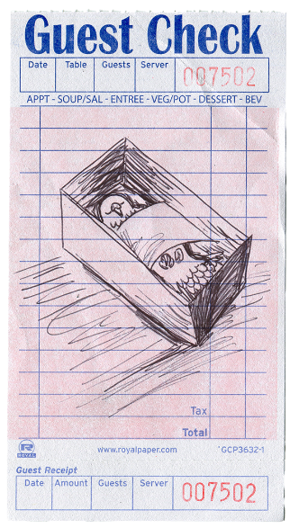
“What is it?” her grandmother asked.
“It looks like Mr. Peepers is dead.”
The grandmother slowly stood and leaned beside her granddaughter. “I thought something was wrong with him. He didn’t say nothing but swear words all day.”
Shelley stared forlornly through the slats of the cage. “Now I’m going to have to go bury him, I guess.”
“Where you plan on doing that?”
“Behind the library.”
“You’re going to get in trouble. Ms. Briff already told you that’s not your own personal cemetery.”
“I don’t care,” Shelley said. “It’s public property. And it’s got the best view of any place in town. Which is the least I can do for him. Besides, I’ve got four other animals buried there already.”
Her grandmother gave her a skeptical look.
“I’ll be quick. Nobody’ll notice. I promise.”
Her grandmother nodded and put one last swipe of frosting in place. Maybe it was the heat, or the bird dying, but the cake looked like a lopsided heart, collapsing in on itself.
3.Outside in the garage, the girl searched for a coffin. There was stack of old shoeboxes her grandmother had collected from “before the war,” but Shelley never had any idea which war she meant. The war in Korea maybe. She found a blue one and climbed up the back porch stairs, stopping on the top step to listen to her grandmother again.
“And where were we, boys and girls? Oh, yes, well, that wily old fox, that wily old fox began to play that fiddle, he began to play and not just any old song, but ‘Wildwood Flower,’ and the woodsman, he had lost one chicken too many and followed those feathers out to the woods, and then he heard that sound. He was standing there in the middle of that darkened forest, and he began to think of his wife, his one true love that had drowned a year before, and then his axe began to feel mighty heavy, and it fell from his shoulder, and he laid it there in the grass where it disappeared, and then he started to march off to where the sound of that lovely voice was calling, deeper and deeper into the midnight forest, and when he looked up, he saw that the trees all wore the sad face of his lovely departed.”
Shelley opened the door and found her grandmother beginning on a second cake, dolloping on pile after pile of white frosting, humming to herself. The girl closed her eyes, took a deep breath, and carefully reached inside the cage for the deceased bird, feeling its cold, reptilian feet. Carefully she deposited the animal in the shoebox, found a piece of blue tissue paper in the junk drawer, placed it over the bird as a ceremonial cloak, and closed the lid.
“Okay, I’ll be back in a bit,” she said and kissed her grandmother on the forehead again. She paused at the door, staring at the profile of her grandmother sitting there frosting the cake, imagining it, like a moment from some soap opera or crime show on television, as the very last time she’d ever see her.
Once more, she heard the police scanner crackle with static.
“Unit 304 to base, unit 304 to base…”
Outside, she placed the shoebox in the wire basket on her bicycle and began to pedal off. She looked around and saw almost everything had gone a faint blue.
Trees passing by looked skeletal, unfamiliar. The sound of the wind hid her unease. She stuck to Fayetteville Road, riding as fast she could.
Up ahead, somewhere in the distance, a pair of lights flashed. A police cruiser fled past in a fury, and Shelley pedaled as hard as she could, desperately trying to keep up.

About the Author
Joe Meno is a fiction writer, playwright, and screenwriter who lives in Chicago. A winner of the Nelson Algren Literary Award, a Pushcart Prize, a Great Lakes Book Award, and a finalist for the Story Prize, he is the author of seven novels: Marvel and a Wonder, Office Girl, The Great Perhaps, The Boy Detective Fails, Hairstyles of the Damned, How the Hula Girl Sings, and Tender as Hellfire. His short story collections are Bluebirds Used to Croon in the Choirand Demons in the Spring. His short fiction has been published in the likes of McSweeney’s, One Story, Swink, LIT, TriQuarterly, Other Voices, Gulf Coast, and broadcast on NPR. He was a contributing editor to Punk Planet, the seminal underground arts and politics magazine. His non-fiction has appeared in The New York Times and Chicago Magazine.

About the Illustrator
Alix Pentecost-Farren is an illustrator, cartoonist and artist. Her work has included stationery design, mud murals, animations, and installations. She went to school for art and design at the North Carolina School of the Arts and then studied illustration and filmmaking at the Rhode Island School of Design before moving to Brooklyn, NY. Her clients include Thrillist, McDonalds, Rising Stars Magazine, Josh Garrels, Margaret Glaspy/ATO Records, Mason Jar Music Films, and more. Her work has been awarded the Communication Arts Award of Excellence, shown in multiple galleries in New York and abroad, published by Martha Stewart Magazine, Harlequin Creature and Keep This Bag Away From Children, and exhibited at Rhode Island Independent Publishing Expo and the Society of Illustrators Museum of Comic and Cartoon Art Festival.

“Star Witness” Copyright © 2017 by Joe Meno.
Illustrations Copyright © 2017 by Alix Pentecost Farren.

